
S

The Lift & Escalator Industry Association
SAFETY Matters
July 2015

Tel: 020 7935 3013
Fax: 020 7935 3321
Email: enquiries@leia.co.uk

Contents
- Silica Dust and RPE
- An Inspector Calls
- Young People at Work
- Back to Work
- Health and Safety Myths
Introduction
Welcome to the July 2015 edition of Safety Matters.
Through this newsletter our aim is to inform you of health and safety issues that may have an impact on the lift and escalator industry. Safety Matters is also available for download from the LEIA member’s website. www.leia.co.uk

Silica Dust and RPE
Silica dust is created when working on silica-containing materials like concrete, mortar and sandstone. Silica dust is the biggest health risk to construction workers after asbestos
Silica dust is not just a nuisance; it can seriously damage your health and can eventually even kill. Regularly breathing this dust over a long time can cause life-changing lung diseases.
The largest amount of silica someone should be breathing in a day after using the right controls is shown left next to the penny
Your employer may already have controls in place. This could include wearing the correct Respiratory Protective Equipment (RPE), designated working areas, Local Exhaust Ventilation, health checks and the storage and maintenance of RPE.
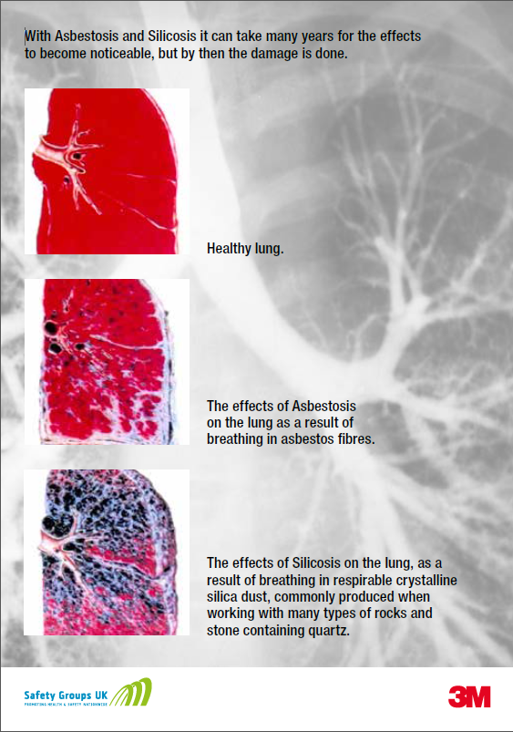
Remember: RPE is the last line of protection and you need to look after it and wear it correctly.
• Always remember to wash your hands before and after removing your RPE.
• Be aware that potentially hazardous fine particles can stay suspended in the air for many hours after completing activities.
• Remember to keep your RPE on when in contaminated environments; don’t move RPE away from the face to talk to colleagues.
• Don’t take contaminated PPE home as you could be exposing your family to a dangerous hazard.
• When clearing up dust, don’t use brooms, brushes or compressed air as this will worsen the problem. Instead, use an approved industrial vacuum cleaner.
• Look after your reusable RPE by cleaning it after each shift and storing it in a clean safe place; using the bag or box provided.
• Remember to clean shave every day if you are required to wear tight fitting respiratory protection; no mask will fit if it has to lie over your stubble.
• Even quick jobs can create more dust than you should be breathing so use your RPE.
BSIF video showing what happens when poorly fitted masks are used:
https://www.youtube.com/watch?v=nrieWGoClfE

AN INSPECTOR CALLS
(with apologies to JB Priestley)
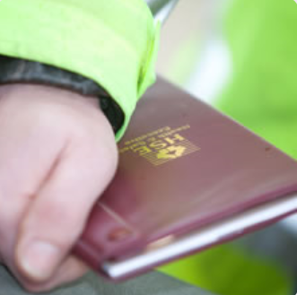
You may be on site when an HSE inspector calls. You may be the person he or she chooses to talk to. What do you do? What do you say?
Remember that the HSE inspector (or Environmental Health Officer or Office of Road and Rail inspector) is a warranted officer with more authority than a member of the public. You should treat them with the same respect as you would a uniformed police officer.
• Contact your manager to let them know an inspector has arrived. Don’t forget you can be prosecuted for not working safely, as well as your employer.
• Don’t be obstructive, be honest, take it seriously, don’t try and impress.
• Don’t make up answers; don’t answer a question that wasn’t asked. If you don’t know the answer, say so, make a note of the question to give you or your manager a chance to respond later.
• Don’t give them original documents, only copies – you may not get them back.
• Treat it as a positive experience, to demonstrate your safe working methods. Give them confidence that you know what you are doing. Check their ID, ask if they have been inducted onto the site, check they have the right PPE on and find some if they haven’t.
The inspector is likely to ask about your training; remember that toolbox talks, videos, equipment demonstrations, employer and site inductions, are all training, as well as formal courses.
YOUNG PEOPLE AT WORK
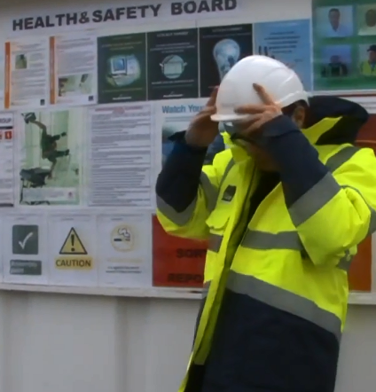
Now is the season when schools and colleges break up, that we start to see more young people and apprentices starting work for the first time. Although they may be full of enthusiasm for their new life, they are rarely completely rounded in their attitudes and abilities. Many feel they know all the answers.
We need to be careful for these young people as their perception of risk is low; they will take risks, because they have not developed the life skills that we take for granted. Many will not be completely physically developed, and will struggle with manual handling tasks that would be easy for others.
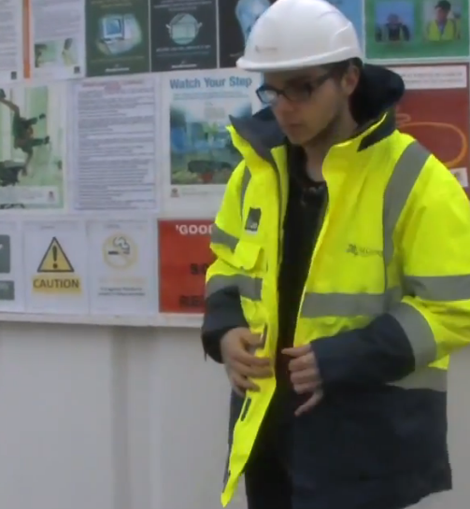
Young people are more susceptible to peer pressure and do not have the same perception of hazards as more experienced workers. Don’t take anything for granted concerning a young person’s experience. Don’t expect them to behave the same way as you. For the first few days everything will be confusing, but they won’t want to admit it for fear of losing face.
Beware of allowing indiscriminate mobile phone and i-pod use; they can be a distraction from the surroundings.
Some sites are specifying a minimum age; it can be as much as 20 years old, so check before you take a young person out.
Be aware that other trades around you may have young people working with them. The other trades may not be a diligent as you.
Watch the video on:
http://www.hse.gov.uk/youngpeople/bsc.htm
BACK TO WORK
No more flip-flops and board shorts. The post-holiday time can be difficult; you had a well-earned rest and now it’s back to the drudge.
Don’t be a victim of lassitude*, remember the five major causes of accidents in the lift and escalator industry:
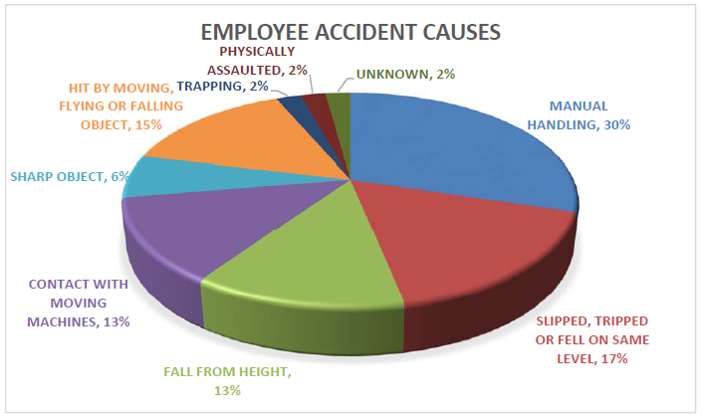
Manual Handling
Slips, Trips and Falls
Hit by a Moving, Flying or Falling Object
Falls from Height
Contact with Moving Machinery
Get familiar with your surroundings again, and reacquaint yourself with the tasks at hand. Think about the safe way to work that you used previously. Refresh your ‘Safety Principles’.
*weariness of body or mind from strain; lack of energy; listlessness.
HEALTH AND SAFETY MYTHS
From the HSE website: http://www.hse.gov.uk/Myth/myth-busting/index.htm
Case 355 - All tools on building sites need to be a maximum of 110V
The enquirer was tasked with carrying out sound insulation tests in houses on a construction site. The site manager asked him if his equipment was battery operated to which his reply was "no, it will need to be plugged into a 230V socket". He asked if there was 230V power in the plots and the site manager said yes it was available but all "tools" on site need to run off a maximum of 110V as this was the company policy.
Mythbusters Panel opinion:
The enquirer appears to have been planning to work in a completed (or nearly) completed house with the electrical system installed and compliant with requirements for electrical installations. This is a significantly lower risk from when the house is under construction. Whilst health and safety law does not ban 230v tools on construction sites, HSE strongly advises that 110v tools are preferable given the wet, dirty and dusty nature of construction sites and the possibility of mechanical damage to cables and tools.
In this instance a standard which is reasonable for a live, temporary, construction site is being applied to a different (domestic) environment where the risks would be much lower and the electrical system permanent and compliant with the latest standards. If a site or company decide to impose a higher (disproportionate) standard in this lower risk environment they can but it is not health and safety law that requires this.

